Designing an Intelligent Accommodation System for Rohingya Refugees: Integrating AI, Sustainability, and Economic Empowerment

MD. Abu Towsif, Farjana Yesmin Opi, Md. Shohanur Rahman Shohan  
Department of Computer Science  
American International University – Bangladesh  
(22-47019-1, 22-47018-1, 22-46013-1)@student.aiub.edu

**Abstract**

This paper presents a framework for an intelligent accommodation system designed to improve living conditions, security, and economic opportunities for Rohingya refugees. Using a systematic literature review (SLR), the study identifies key challenges and proposes an AI-driven model incorporating sustainable infrastructure and community-focused strategies. The framework aims to enhance resource management, security, and productivity within refugee camps, providing a comprehensive approach to addressing both immediate and long-term needs. Findings underscore the potential for integrating technology and local knowledge to foster self-sufficiency and stability. This research offers valuable insights for policymakers and humanitarian organizations, guiding innovative solutions for refugee support and integration.

**Keywords:** Sustainable Refugee Housing, AI-Driven Solutions, Rohingya Refugee Accommodation, Refugee Productivity, Economic Empowerment

INTRODUCTION

The Rohingya, an ethnic minority from Myanmar, have faced decades of systemic persecution, leading to mass displacement. With nearly 1,000,000 Rohingya refugees (United Nations High Commissioner for Refugees, n.d.) currently residing in makeshift camps in Bangladesh, innovative solutions to these crises are urgently needed that not only provide basic accommodation but also promote productivity and self-sufficiency (Milton et al., 2017). The influx of refugees into Bangladesh, particularly in the Cox’s Bazar region, has placed immense pressure on resources and infrastructure. Traditional refugee camps often focus solely on providing immediate relief, such as food and shelter, without addressing long-term sustainability and the potential for refugees to contribute economically and socially (Bhatia et al., 2018).

To illustrate the gravity of the situation, consider the story of Tasmin, a 51-year-old Rohingya woman who fled Myanmar’s Rakhine State after horrific violence was waged against her ethnic minority group in late 2017. Tasmin and her five children escaped to the forests behind their home, hiking for eleven days before reaching the Naf River, which marks the border between Myanmar and Bangladesh. Tasmin’s family was resettled in Kutupalong, where they joined nearly one million other Rohingya refugees. Tasmin's story reflects the extreme trauma and severe hardships that all Rohingya refugees endure in these overcrowded camps, where they face dire living conditions, including inadequate shelter, food shortages, and a lack of basic sanitation and healthcare (Relief International, 2019).

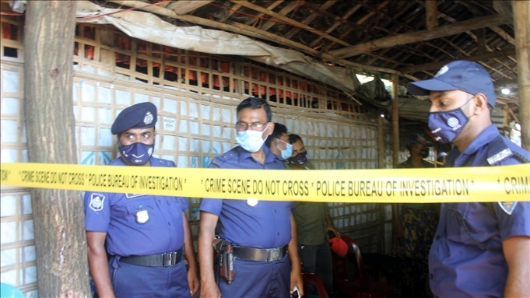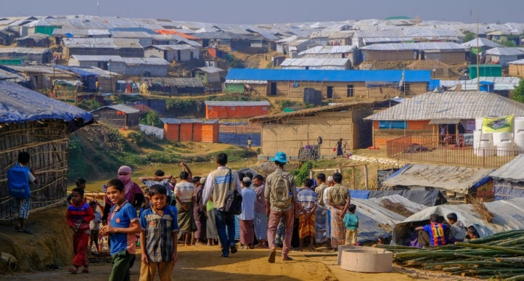

Figure 2 - Police guard madrassa after Rohingya attack in Cox’s Bazar, Oct. 26, 2021. (Benar News, 2021)

Figure 1 - Kutupalong Refugee Camp (Humanity & Inclusion Canada, n.d.)

Adding to these challenges, an alarming rise in crimes, including murders and drug offenses, has been reported in the camps, linked to armed groups like ARSA and RSO (The Daily Star, 2023). The situation is worsened by Rohingya refugees obtaining fake Bangladeshi IDs, creating instability and fear (Dhaka Tribune, 2023). Contributing factors include lack of economic opportunities and a sense of hopelessness, with jobless youths turning to crime for survival and armed groups competing in illegal activities, further escalating violence (Dhaka Tribune, 2023). The problems that this research aims to address can be broadly summarized into two main issues:

* **Inadequate living conditions and lack of long-term sustainability**: Current refugee accommodations hinder the economic self-sufficiency and social productivity of Rohingya refugees.
* **Escalating security problems within camps**: Issues such as crime and the misuse of identification documents further destabilize the already precarious environment.

This paper addresses the critical need to rethink refugee accommodation from a perspective that includes productivity, self-reliance, and enhanced security.

***Related Studies***

In order to address the above discussed problems several studies examined conditions of Rohingya refugee camps. Bhatia et al. (2018) highlight inadequate facilities and economic opportunities but offer no long-term solutions. Milton et al. (2017) focus on health challenges from overcrowding and poor sanitation but overlook socio-economic factors and technology's role. Karin et al. (2020) emphasizes the critical dearth of food, inadequate housing facilities, and poor access to health services in Rohingya refugee camps but do not explore the potential role of technological advancements in addressing these issues. Hossain et al. (2020) address rising crime and armed groups but do not explore how AI could enhance security.

Despite the valuable contributions of these studies, there is a noticeable gap in the literature regarding integrated solutions that combine sustainable living conditions with productivity-enhancing features and advanced technologies like AI. None of the existing research comprehensively addresses the need for a holistic accommodation system that not only meets the basic needs of refugees but also empowers them to achieve economic self-sufficiency and social productivity while ensuring their security.

This research aims to fill that gap by proposing an intelligent accommodation system that incorporates AI to optimize resource allocation, enhance security, and support economic integration within the refugee camps. By addressing these gaps, this study will contribute significantly to the field of humanitarian aid and refugee studies, offering a model that can be adapted and implemented in similar contexts globally.

***Research Objectives***

This research proposes an intelligent accommodation system for Rohingya refugees that combines sustainable living, productivity enhancement, and improved security. The objective is to develop a framework that addresses immediate needs such as shelter and healthcare, while also focusing on long-term sustainability through environmental practices and resource management. The system will integrate economic activities to promote self-reliance and utilize AI to address security issues and optimize resources. The study will present a conceptual model to explore the answer of "How to develop an intelligent accommodation system for Rohingya refugee that supports productivity, ensures security, and leverages AI?"

***Research Contributions***

This study contributes to humanitarian aid, refugee studies, and AI-driven social innovation by presenting a framework for intelligent accommodation systems tailored to Rohingya refugees. It provides insights for policymakers and organizations on using AI to create sustainable, secure environments while enhancing refugee productivity. By integrating AI in resource management and security, the research offers solutions that reduce refugee dependency, promote self-sufficiency, and relieve the socio-economic burden on host countries

methodology

The methodology of this study is based on a systematic literature review (SLR) approach, designed to comprehensively evaluate existing research and literature relevant to the development of intelligent accommodation systems for Rohingya refugees. This approach ensures a thorough and unbiased collection of data that contributes to forming a robust framework for addressing the research problem. The SLR method follows the guidelines set by Kitchenham et al. (2010) and Petersen et al. (2008), which emphasize the importance of systematic data collection and analysis.

## *Search Strategy*

The search strategy targeted relevant academic sources across IEEE Xplore, SpringerLink, ScienceDirect, ACM Digital Library, IGI Global, Google Scholar, and Wiley Online Library. These databases offer extensive coverage of technological and humanitarian literature, essential for the interdisciplinary nature of this research.

#### Keywords and Boolean Logic

A combination of carefully selected keywords was utilized to refine and target the search results. Boolean operators were applied to manage and expand the search results effectively. The following keywords and Boolean logic were used:

* "Rohingya refugees" AND "accommodation system" AND "artificial intelligence"
* "refugee productivity" OR "sustainable refugee camps"
* "AI in refugee security" AND "systematic review"

This strategic combination of search terms helped ensure the search was both comprehensive and focused on relevant studies.

#### Forward and Backward Search Techniques

In addition to the primary search using databases, both forward and backward citation search techniques were employed. This included reviewing the references cited in key articles (backward search) as well as identifying more recent publications that cited these articles (forward search). This approach ensured that all relevant literature, including the most recent studies, was considered in the review process. This comprehensive search strategy minimizes the risk of omitting any critical studies or emerging research.

#### Inclusion and Exclusion Criteria

To ensure the relevance and quality of the reviewed literature, specific inclusion and exclusion criteria were applied throughout the selection process.

### *Inclusion Criteria*

* Peer-reviewed journal articles and conference papers.
* Studies focusing on refugee accommodation, AI applications in humanitarian settings, and security.
* Publications in English.
* Articles published between 2000 and 2024.

#### Exclusion Criteria

* Non-peer-reviewed articles, such as opinion pieces or editorials.
* Studies not explicitly addressing AI or accommodation systems in refugee contexts.
* Articles where only titles were relevant but lacked substance in abstracts or full texts.
* Publications without sufficient detail or methodological rigor.

## *Selection Process*

The selection process was designed to systematically screen studies based on their relevance to the research question

#### Initial Screening

An initial search of the academic databases yielded 87 articles after applying the defined keywords. Titles and abstracts of these papers were reviewed to determine their relevance to the research question. This initial screening was based on whether the articles mentioned AI, refugee accommodation, and security systems, among other factors.

#### Secondary Filtering

Following the initial screening, the inclusion and exclusion criteria were applied to refine the list. This stage involved filtering out studies that lacked peer-reviewed rigor or relevance to AI-driven accommodation systems for Rohingya refugees. After this stage, 30 articles remained for further review.

#### Final Selection

A detailed review was conducted on the remaining 30 articles, which led to a final selection of 11 studies. These were chosen based on their direct relevance to the research objectives, as well as their methodological rigor. Both free full-text articles and those available only through abstracts were considered in this review, with abstracts used to extract data when full texts were not accessible.

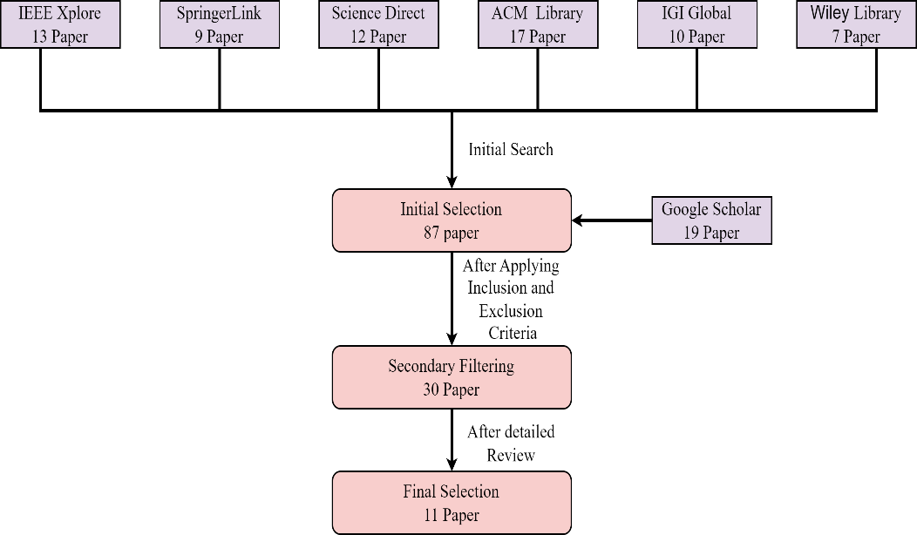

**Figure 3 -** Literature Search and Article Selection for Systematic Review

## *Data Extraction and Synthesis*

Data extraction used a standardized approach to ensure consistency, collecting detailed information from all accessible sections of freely available articles, including abstract, methodology, results, and discussion. For articles with limited access, the focus was on gathering the most relevant data from the available content.

#### Data Extraction Process

A standardized data extraction form was used to methodically collect information from each study. For fully accessible articles, data were extracted from the abstract, introduction, methodology, results, and conclusions. For articles with limited access, the extraction process focused on the most pertinent information related to developing an intelligent accommodation system for Rohingya refugees.

#### Quality Assessment

Quality assessment was based on citation count, journal impact, and methodological rigor. This ensured the inclusion of high-quality studies, enhancing the credibility and impact of the research findings.

**RESEARCH DATA**

The following table summarizes the key findings from the reviewed literature, highlighting relevant insights and data that inform the development and validation of the proposed solution

|  |
| --- |
| Top row contains citations with author name, while the rows below the citation contains findings from the reviewed literature |
| **Alam et al. (2018)** |
| The study proposes a cloud-based system to improve refugee accommodation management by centralizing resource tracking and refugee information. Biometric identification enhances security and resource allocation, creating a more efficient and productive environment. |
| **Wardeh and Marques (2021)** |
| The review highlights the importance of sustainable planning in refugee camps by integrating local knowledge and technology. Focus areas include health, education, and economic growth, with long-term policies crucial for improving the Rohingya community's quality of life. |
| **Dala et al. (2018)** |
| The paper calls for improved refugee shelter design by integrating urban planning to boost productivity and security. It critiques rigid bureaucratic systems, advocating for more flexible, self-determined living arrangements to empower refugees, especially the Rohingya. |
| **Sabie and Ahmed. (2019)** |
| The paper highlights the need for inclusive technology design to overcome barriers faced by refugees, especially women. An intelligent accommodation system could address these challenges, improving resource access, digital skills, and security for Rohingya refugees. |
| **Marji and Kohout (2022)** |
| The paper advocates for using AI in refugee camps to improve spatial organization, enhance living conditions, and ensure security through better resource management. Involving refugees in the design process fosters more sustainable and productive accommodation solutions. |
| **Hossain et al. (2020)** |
| The paper emphasizes a structured approach to the Rohingya refugee crisis, focusing on security and safe return while addressing vulnerabilities and resource limitations. It suggests that an intelligent accommodation system could enhance productivity and security, highlighting the need for international cooperation and humanitarian support to ensure sustainability. |
| **Easen and Binatli (2017)** |
| The paper highlights how the influx of refugees, like Syrians in Turkey, affects local labor markets by increasing unemployment. It emphasizes the need for integration strategies to enhance productivity and security, guiding the development of an intelligent accommodation system for Rohingya refugees to stabilize labor markets and ensure secure living conditions. |
| **İncetahtacı (2024)** |
| The paper stresses the need for structured solutions to the Rohingya crisis, focusing on security, safe return, and international cooperation. It suggests an intelligent accommodation system to enhance productivity and address security concerns. |
| **Georgious et al. (2023)** |
| The paper highlights how refugee influxes, like Syrians in Turkey, affect local labor markets, underscoring the importance of integration strategies. These insights can inform the development of secure and productive accommodation systems for Rohingya refugees. |
| **Filipski et al. (2020)** |
| The study emphasizes the need for addressing legal, resource, and cultural barriers to improve refugee youth productivity. Collaborations between universities and NGOs can empower refugees, enhancing their economic contributions and social cohesion. |
| **Wolf (2014)** |
| The paper identifies the Rohingya crisis as a non-traditional security threat in Bangladesh, fueling religious fundamentalism and straining governance. Addressing transnational crime and distinguishing between moderate and radical elements is essential for regional stability. |

**ANALYSIS AND DISCUSSION**

Based on the above findings from the selected papers, the proposed solution integrates an AI-driven system for resource tracking, identification, and security. It enhances refugee living conditions with sustainable infrastructure and promotes self-sufficiency through employment and community integration within the camps.The proposed solution integrates an AI-driven system to enhance resource management, security, and living conditions for Rohingya refugees. By utilizing AI for centralized data management and biometric identification, as suggested by Alam et al. (2018), the system will improve resource tracking and security. It also aims to foster self-sufficiency through sustainable infrastructure and eco-friendly practices, such as solar power, and by creating employment opportunities within camps (İncetahtacı, 2024; Filipski et al., 2020). This approach will not only improve living conditions but also promote economic integration and community cohesion.

Additionally, the proposed solution incorporates AI-based surveillance and real-time monitoring to bolster security and ensure safety (Hossain et al., 2020). By integrating refugees into local economies and addressing legal and cultural barriers through education and mentorship programs, the system will support both the refugees and host communities. This comprehensive approach aims to provide a holistic solution that addresses immediate needs, enhances productivity, and fosters long-term stability within the camps.

The diagram below illustrates the proposed solution, integrating key technological and community-focused strategies based on the proposed solutions

The diagram below illustrates the proposed solution, integrating key technological and community-focused strategies based on the proposed solutions

Figure 4 - Diagram of Proposed Ai driven accommodation system for Rohingya refugees

The proposed intelligent accommodation system aligns with findings from existing literature, addressing identified gaps in current refugee support systems. By incorporating AI-driven resource management, sustainable infrastructure, and economic empowerment, the solution is both theoretically sound and practically feasible. Empirical studies, such as those by İncetahtacı (2024) and Filipski et al. (2020), support the use of AI in improving resource allocation and living conditions, reinforcing the solution’s potential effectiveness.

Conclusion

This paper presents a framework for an intelligent accommodation system designed to address the multifaceted challenges faced by Rohingya refugees. The proposed solution aims to enhance living conditions, security, and economic opportunities by integrating AI-driven management systems with sustainable infrastructure and community-focused strategies. The framework is built upon a comprehensive review of existing literature and highlights the need for innovative approaches to improve both immediate relief and long-term self-sufficiency for refugees.

While the framework provides a robust theoretical model, it is limited by its conceptual nature and the lack of practical implementation. Future research should focus on testing and refining the proposed system in real-world settings to assess its effectiveness and feasibility. Additionally, exploring scalability and adaptability for different refugee contexts will be essential for validating and extending the framework's applicability. Addressing these limitations will help in further developing practical solutions that can be effectively deployed and evaluated.

**REFERENCES**

Ahad, S. S. (2024). *Detectives reveal how Rohingyas obtain fake documents.* Available at https://www.dhakatribune.com/bangladesh/crime/340383/detectives-reveal-how rohingyas-obtain-fake. Accessed on September 14, 2024.

Alam, F. R., Munir, M. B., Ishrak, S., Hussain, S., Reza, F., Khan, N. S., Tumpa, S. N. & Karim, M. M. (2018). *An automated cloud-based digitized management system for Rohingya refugee camp in Bangladesh.* 2018 International Conference on Electrical, Computer, and Communication Engineering (ECCE), Chonburi, Thailand.

Barua, S., & Chowdhury, K. R. (2021, October 26). *Bangladesh: Rohingya express fear after killings of leader, 6 others.* Available at https://www.benarnews.org/english/news/bengali/camp-fears-10262021163429.html. Accessed on September 13, 2024.

Bhatia, A., Mahmud, A., Fuller, A., Shin, R., Rahman, A., Shatil, T., Sultana, M., Morshed, K. A. M., Leaning, J., & Balsari, S. (2018). The Rohingya in Cox's Bazar: When the Stateless Seek Refuge. *Health and Human Rights, 20*(2), 105-122.

Dala, A., Darweesh, A., Misselwitz, P., & Steigemann A. (2018). Planning the Ideal Refugee Camp A Critical Interrogation of Recent Planning Innovations in Jordan and Germany. *Urban Planning, 3*(4), 64.

Easen, O., & Binatli, A. O. (2017). The Impact of Syrian Refugees on the Turkish Economy: Regional Labour Market Effects. *Social Sciences, 6*(4), 129.

Filipski, M. J., Rosenbach, G., Tiburcio, E., Dorosh, P., & Hoddinott, J. (2020). Refugees Who Mean Business Economic Activities in and Around Rohingya Settlements in Bangladesh. *Journal of Refugee Studies, 34*(1), 1202-1242.

Georgious, T., Baillie, L., & Shah, R. (2023). Investigating Technology Concepts to Support Rohingya Refugees in Malaysia. doi:10.48550/arXiv.2304.01617.

Handicap International. (n.d.). *Almost one million Rohingya refugees living in Bangladesh.* Available at https://www.hi-canada.org/en/news/almost-one-million-rohingya-refugees-living-in-bangladesh. Accessed on September 13, 2024.

Hossain, S., Zhang, H., Hossain, M. S., & Yun, L. (2020). Rohingya Refugee Crisis: Security Concerns for Bangladesh. *South Asian Journal of Social Studies and Economics, 8*(2), 24-34.

İncetahtacı, N. (2024). The role of university-NGO cooperation in increasing the entrepreneurial skills of youth: An evaluation specific to refugee youth.*International Journal of Education, 39*(2), 507-523.

Karin, S., Chowdhury, M. A., Hasnat, M. A., & Tarin, N. J. (2020). Status of Rohingya in refugee camps of Bangladesh: A review study. *Open Access Library Journal*, *7*(9), 1-24.

Khan, M. J., & Jinnat, M. A. (2023). *Refugee camps: Killings, narco-crimes rise.* Available at https://www.thedailystar.net/news/bangladesh/crime-justice/news/refugee-camps-killings-narco-crimes-rise-3402601. Accessed on September 14, 2024.

Marji, N., & Kohout, M. (2022). *From Temporary Shelter to Permanent Dwelling: Optimizing the Spatial Organization of Refugee Camps in Jordan through Artificial Intelligence.* Academic Mindtrek 2022: 25th International Academic Mindtrek conference, Tampere, Finland.

Milton, A. H., Rahman, M., Hussain, S., Jindal, C., Choudhury, S., Akter, S., Ferdousi, S., Akter Mouly, T., Hall, J., & Efird, J. T. (2017). Trapped in Statelessness: Rohingya Refugees in Bangladesh. *International Journal of Environmental Research and Public Health, 14*(8), 942. https://doi.org/10.3390/ijerph14080942.

Relief International. (2019). *Rohingya Crisis: "I’ve Never Shared My Story Before."* Available at https://www.ri.org/rohingya-crisis-ive-never-shared-my-story-before/. Accessed on September 12, 2024.

Sabie, D., & Ahmed, S. I. (2019). *Moving into a technology land: exploring the challenges for the refugees in Canada in accessing its computerized infrastructures.* COMPASS '19: Proceedings of the 2nd ACM SIGCAS Conference on Computing and Sustainable Societies, Accra, Ghana.

United Nations High Commissioner for Refugees (UNHCR). (n.d.). *Bangladesh - Refugee Situation.* Available at https://data.unhcr.org/en/country/bgd. Accessed on September 12, 2024.

Wardeh, M., & Marques, R. C. (2021). Sustainability in refugee camps: A systematic review and meta-analysis. *Sustainability, 13*(14), 7686.

Wolf, S. (2014). The Rohingyas crisis: a security perspective from Bangladesh. *APSA Comment*, *11*(21), 1-11.